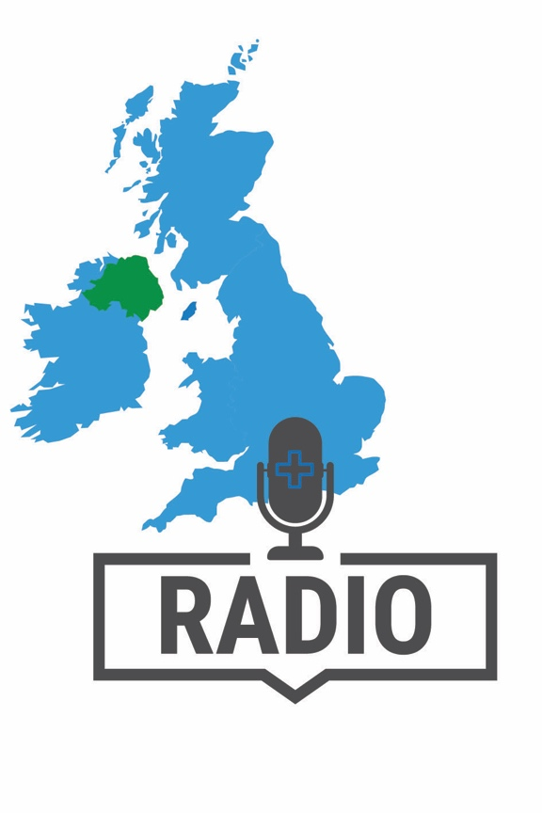
How about calling into one of the many radio phone-in
shows in Northern Ireland where the presenters are generally eager to hear about the experiences of health care workers in relation to the coronavirus pandemic?

Here are details for some of the programmes you
may wish to call into:

BBC Radio Ulster
The Nolan Show, weekdays, 9-10.30am.
Email: nolan@bbc.co.uk

Talkback, weekdays, noon-1.30pm.
Phone: 03030 80 55 55
Email: talk.back@bbc.co.uk
Text: 81771

Evening Extra, weekdays, 4-6pm.
Text: 81771

On Your Behalf (consumer show), Saturdays, 9.45-10.30am.
Email: oyb@bbc.co.uk

U105
Frank Mitchell, weekdays, 9-noon.
Phone: 02890 333105
Email: studio@u105.com
Text: 07766 105 105

Here are some key messages you might wish to get across, in your own words.

Key messages:

- Pharmacies are on the frontline of the national effort to limit the impact of coronavirus and to keep people well.

- As well as handling a massive increase in demand for advice and medicines, we’re also continuing to provide urgent care, help for minor illnesses and supporting people with long term medical conditions.

- Pharmacy teams are there for you in this crisis. But please remember to respect our safety and do not to go to the pharmacy if you are, or might be, infected with coronavirus!

- Please be patient with pharmacy staff, who are doing their utmost, under extreme pressure, to support you at this time; treat them with courtesy, as you yourself would wish to be treated.

- Please only buy the medicines you need now for you and your family; this will help to avoid creating difficulties for others, so that everyone in your community gets the medicines they need.

Please feel free to contact the NPA press office for advice and up-to-the-minute Q&As before you phone-in. Email: press@npa.co.uk

